A funeral for Venice
[Saturday, November 14, 2009]

The population of Venice has dropped below 60,000. A funeral for Venice is intended as an ironic and humorous response to very serious problems: population is falling; traditional stores are closing, being replaced by junk shops; zoning violations and the black market are taking over the streets and alleyways; erosion from motortraffic is destroying historical buildings and eating away at the banks of the canals; our elderly live in dilapidated housing and our youth are forced to move away.

Population in Venice's Historical Center from 1993 to 2009
period under mayors Cacciari-Costa-Cacciari
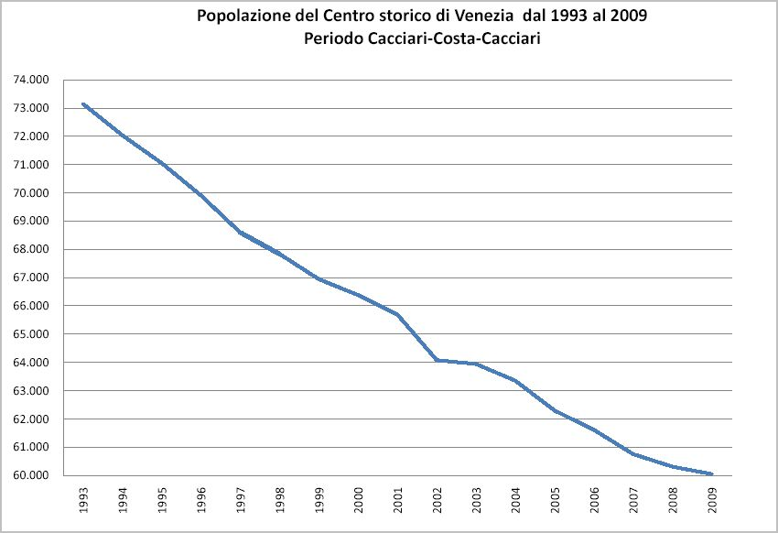
Action by the city government to improve this disastrous situation has been conspicuously absent: public assistance for the purchase of starter homes has not been offered since 2003; access to city waiting lists for public housing is blocked; state owned housing remains for a good portion un-rented. There are no boat docking spaces for residents. The needs of those that still live in Venice are not taken into consideration. Many of the local officials, supported in part by those leaning to the easy earnings brought by the tourist trade, have been unable to avoid the endless social decline. The citizens of Venice must also realize who they are. They need to have greater respect for their city.

The millions of Euro of public monies made available to Venice should be spent on renovating housing for young couples, for more efficient transportation, for those that want to live and work in Venice, for services and infrastructure for residents. The objective of those who would govern Venice in the coming years should be to reach a minimum threshold of residents in the historical center which can serve to restore its social and economic vitality. Ward off the loss of identity that the city of Venice is facing. The identity and the cultural riches of a region can only be guaranteed by the constancy of a stable resident population, and not by roughly 80,000 daily commuters. The population decline of Venice must be treated as a problem, and not as a “physiological phenomenon” presented by the transfer of residents to the mainland around the lagoon, even if part of the same city government.

AAA DESPERATELY SEEKING M/F SINGLES/COUPLES/FAMILIES TO BE VENETIANS!

IT IS YOUR RESPONSIBILITY TO KEEP THE CITY ALIVE

